Computing in Epidemiology and Biostatistics
Find the root for a function; exact confidence intervals
Wan-Yu Lin

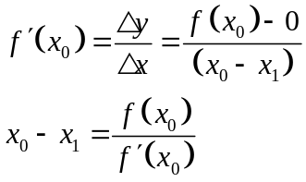
f(X₀)

f(X₁)

f(X₂)

X_{n}
X₀
X₁
X₂
X₃

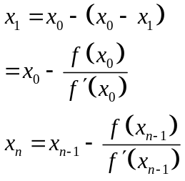

The Newton-Raphson method does not always work. There are two requirements:
- The function 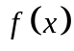 should be differentiable in the desired interval. Therefore, 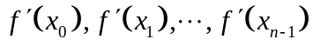 exist.
- cannot be 0. (the denominator of 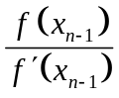 cannot be 0)

The code below implements the Newton-Raphson algorithm in a function newtonraphson. To use it, you first need to create a function, ftn(x) say, which returns the vector (f(x), f′(x)).

newtonraphson(ftn, x0, tol = 1e-9, max.iter = 100) has four inputs:

ftn is the name of a function that takes a single numeric input and returns a numeric vector of length two. If x is the input then the output must be (f(x), f′(x)).
x0 is the initial value for the algorithm. (Be careful when assigning the initial value)
tol is such that the algorithm will stop if | f(x_{n})-0 | ≤ tol, with default 10⁻⁹.
max.iter is such that the algorithm will stop when n = max.iter, with default 100.

Function for the Newton-Raphson method:
More strict, stringent if you specify a smaller tolerance value
newtonraphson <- function(ftn, x0, tol = 1e-9, max.iter = 100) {
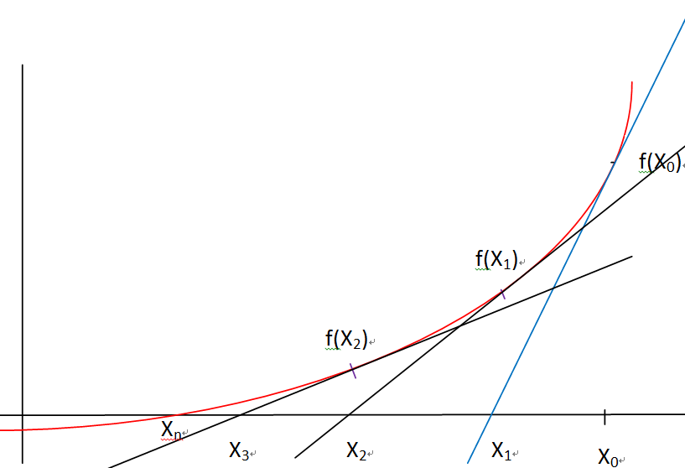
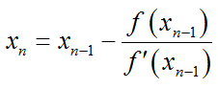
x <- x0 # x0: the initial value
fx <- ftn(x)
iter <- 0
while ((abs(fx[1]) > tol) & (iter < max.iter)) {
x <- x - fx[1]/fx[2]
fx <- ftn(x)
iter <- iter + 1
cat("At iteration", iter, "value of x is:", x, "\n")
}
if (abs(fx[1]) > tol) {
cat("Algorithm failed to converge\n")
return(NULL)
} else { # abs(fx[1]) <= tol
cat("Algorithm converged\n")
return(x)
}
}

Please find the root for 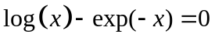. We first make a plot:
x <- seq(0,10,0.01)
y <- log(x)-exp(-x)
plot(x,y)

We then write a function to incorporate  and its first derivative:
ftn4 <- function(x) {
fx <- log(x) - exp(-x)
dfx <- 1/x + exp(-x)
return(c(fx, dfx))
}
newtonraphson(ftn4, 2, 1e-06)

Please find the root for 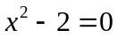. We first make a plot:
x <- seq(-4,4,0.01)
y <- x^2-2
plot(x,y)

We then write a function to incorporate 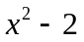 and its first derivative:
ftn5 <- function(x) {
fx <- x^2 - 2
dfx <- 2*x
return(c(fx, dfx))
}
newtonraphson(ftn5, 2, 1e-06)
newtonraphson(ftn5, -2, 1e-06)

Ex 16：Please use the Newton-Raphson method to find the root for 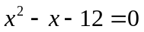.

Please find the root for . We first make a plot:
x <- seq(-5,5,0.01)
y <- x^2-x-12
plot(x,y)

ftn6 <- function(x) {
fx <- x^2-x-12
dfx <- 2*x-1
return(c(fx, dfx))
}
newtonraphson(ftn6, 2, 1e-06)
newtonraphson(ftn6, -2, 1e-06)
Ex 17：Consider a class with 20 students, if the probability of passing the final exam is p and we observe 3 students passing the final exam.

- Please find the 95% exact confidence interval for p.

Binomial distribution (p)
[p_{L}, p_{U}] covers 95% probability.
p_{L} means the final exam is very difficult, how difficult the final exam may be?
P(3 students passed) + P(4 students passed) + P(5 students passed) +…. + P(20 students passed) = 0.025

- [ P(3 students passed) + P(4 students passed) + P(5 students passed) +…. + P(20 students passed) ] = 1-0.025

P(0 student passed) + P(1 student passed) + P(2 students passed) = 0.975 => really difficult

(The probability that few students (0, 1, or 2) passed the final exam is very high, 0.975, meaning that the exam is really difficult.)

p_{U} means the final exam is relatively simple.
4 outcomes : few students passed the final exam
P(3 students passed) + P(2 students passed) + P(1 student passed) + P(0 student passed) = 0.025 => relatively simple

(The probability that few students (0, 1, 2, or 3) passed the final exam is very low, 0.025, meaning that the exam is relatively simple.)

Hint：
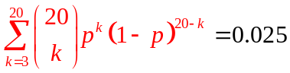 or equivalently 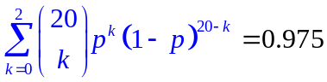
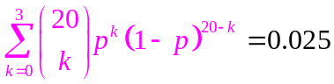
R command for 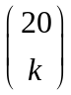 is choose(20,k)

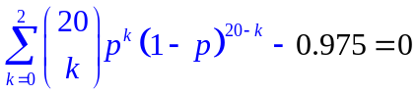
fp=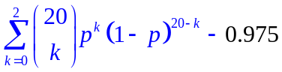
dfp=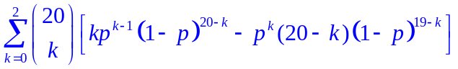

- Please find the 95% asymptotic confidence interval for p.
(asymptotic: based on the central limit theorem)

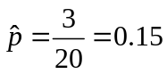 (point estimate)
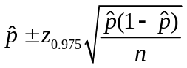

Homework (8 points, please pay attention to all the words in this orange box):
Ex 17-1：Consider a class with 100 students, if the probability of passing the final exam is p and we observe 20 students passing the final exam.

- Please find the 95% exact confidence interval for p.
Requirements: please start from making plots to decide the initial values (2 points), and then define your functions and use our newtonraphson (ftn7, ftn8, etc) (4 points)

- Please find the 95% asymptotic confidence interval for p. (2 points)
(asymptotic: based on the central limit theorem)
Requirements: please calculate 95% asymptotic confidence interval based on .

Please note: Using the “binom” package to answer this homework will be scored as 0, although you may use that package to check your own answers.

